Week 2: Customer Experience Analysis Using E-Commerce Customer Support Data
Customer experience is one of the most important factors influencing customer satisfaction, loyalty, and business growth in the e-commerce industry. Every interaction between a customer and a support team contributes to the overall perception of a company's service quality.
This project focuses on analyzing customer support data to evaluate service performance, identify response patterns, measure customer satisfaction, and uncover operational challenges. By examining customer interactions, response times, issue categories, support channels, and resolution outcomes, the analysis provides valuable insights that help organizations improve customer service efficiency and enhance customer retention.
The project was carried out using Microsoft Excel, where data cleaning, exploratory analysis, KPI development, Pivot Tables, Pivot Charts, and an interactive dashboard were used to transform raw customer support records into meaningful business insights.
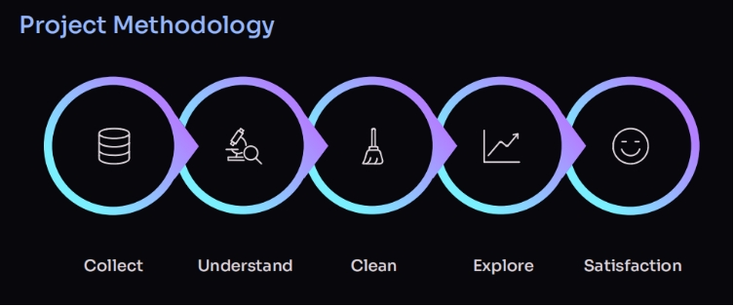
2.2.2 Objectives
Primary Objectives
- To analyze customer support interactions and evaluate service performance.
- To identify factors affecting customer satisfaction and issue resolution.
- To measure key customer support KPIs using Excel.
- To develop an interactive dashboard for monitoring customer experience.
- To generate business insights that support service improvement and customer retention.
Specific Analytical Goals
- Analyze customer satisfaction across different support channels.
- Evaluate response time and issue resolution performance.
- Compare ticket volumes by issue category.
- Study customer interactions across various communication channels.
- Identify trends that impact customer satisfaction.
- Design an interactive dashboard for business decision-making.

2.2.3 Methodology
a) Dataset Preparation
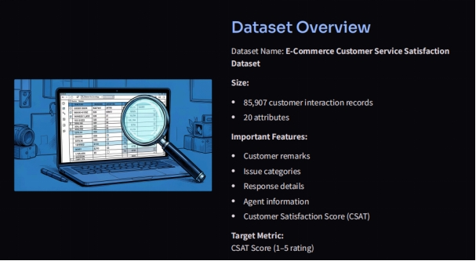
- Imported the E-Commerce Customer Support dataset into Microsoft Excel.
- Reviewed the dataset for missing values, duplicate records, and inconsistent entries.
- Standardized categorical variables such as support channel, issue category, and ticket status.
- Verified numerical and date-related fields for analytical consistency.
- Prepared the dataset for dashboard development and reporting.
b) Data Analysis
The dataset was analyzed using Microsoft Excel features including:
- Pivot Tables
- Pivot Charts
- Sorting and Filtering
- Conditional Formatting
- KPI Calculations
The following business metrics were evaluated:
- Total Customer Support Tickets
- Average Customer Satisfaction Score
- Average Response Time
- Average Resolution Time
- Issue Category Distribution
- Support Channel Performance
- Resolution Status Analysis
c) Dashboard Development
An interactive Excel dashboard was designed containing:
- KPI Cards
  - Total Tickets
  - Average Satisfaction Score
  - Average Response Time
  - Average Resolution Time
- Customer Satisfaction Analysis
- Issue Category Distribution
- Support Channel Performance
- Resolution Status Analysis
- Ticket Volume Trends
- Interactive Slicers for dynamic filtering and business exploration

2.2.4 Results and Insights
a) Customer Support Performance
The dashboard provided a comprehensive overview of customer support operations by summarizing ticket volume, customer satisfaction, response efficiency, and resolution effectiveness.
b) Customer Satisfaction Analysis
- Customer satisfaction varied across different support interactions.
- Faster issue resolution generally resulted in higher satisfaction ratings.
- Delayed responses were associated with lower customer satisfaction.
c) Issue Category Analysis
- Certain issue categories generated significantly more customer support requests than others.
- Frequently reported issues indicate opportunities for operational improvements and preventive measures.
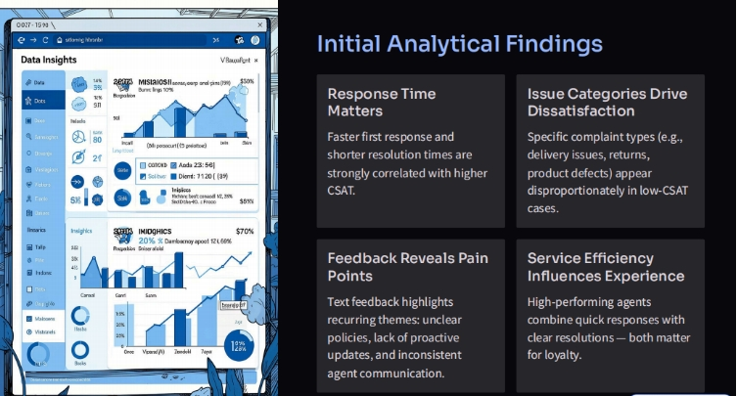
d) Response Time Analysis
- Response time emerged as one of the strongest factors affecting customer experience.
- Reducing response delays can significantly improve customer satisfaction and service quality.
e) Support Channel Performance
- Customer interactions differed across support channels such as Email, Chat, and Phone.
- Some communication channels handled larger ticket volumes while maintaining better response efficiency.
f) Resolution Analysis
- Successfully resolved tickets contributed positively to customer experience.
- Monitoring unresolved or delayed tickets helps organizations improve service efficiency.

2.2.5 Recommendations
- Reduce customer response time by improving support team efficiency.
- Prioritize frequently reported issue categories for faster resolution.
- Strengthen support channels with high customer demand.
- Monitor customer satisfaction regularly through dashboard KPIs.
- Use customer feedback to improve products and support services.
- Implement proactive customer support strategies to reduce recurring issues.

2.2.6 Conclusion
This project successfully analyzed customer support data to evaluate overall customer experience using Microsoft Excel.
Through data cleaning, exploratory analysis, KPI development, Pivot Tables, Pivot Charts, and dashboard visualization, meaningful insights were generated regarding customer satisfaction, response efficiency, issue trends, and support performance.
The interactive dashboard provides decision-makers with valuable information to monitor service quality, improve operational efficiency, enhance customer satisfaction, and strengthen long-term customer relationships.

